MATHEMATICS METHODS

MAWA Semester 1 (Unit 1) Examination 2015

Calculator-free

Marking Key

Section One: Calculator-free (60 Marks)

Question 1(a)
Solution
Marking key/mathematical behaviours | Marks
- Determines | 1

Question 1(b)
Solution
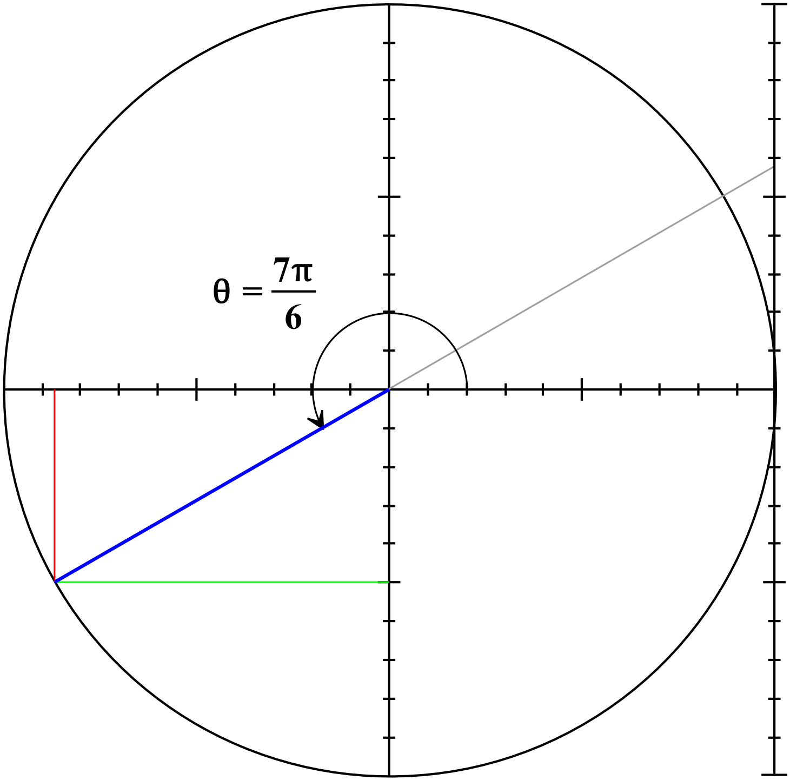

by using the right triangle identity or
by knowledge of exact values
Similarly
Marking key/mathematical behaviours | Marks
- indicates use of or uses meaningfully  - states correct exact value of (accept )  - indicates use of  - states correct exact value of (accept ) | 1  1  1  1

Question 1(c)
Solution
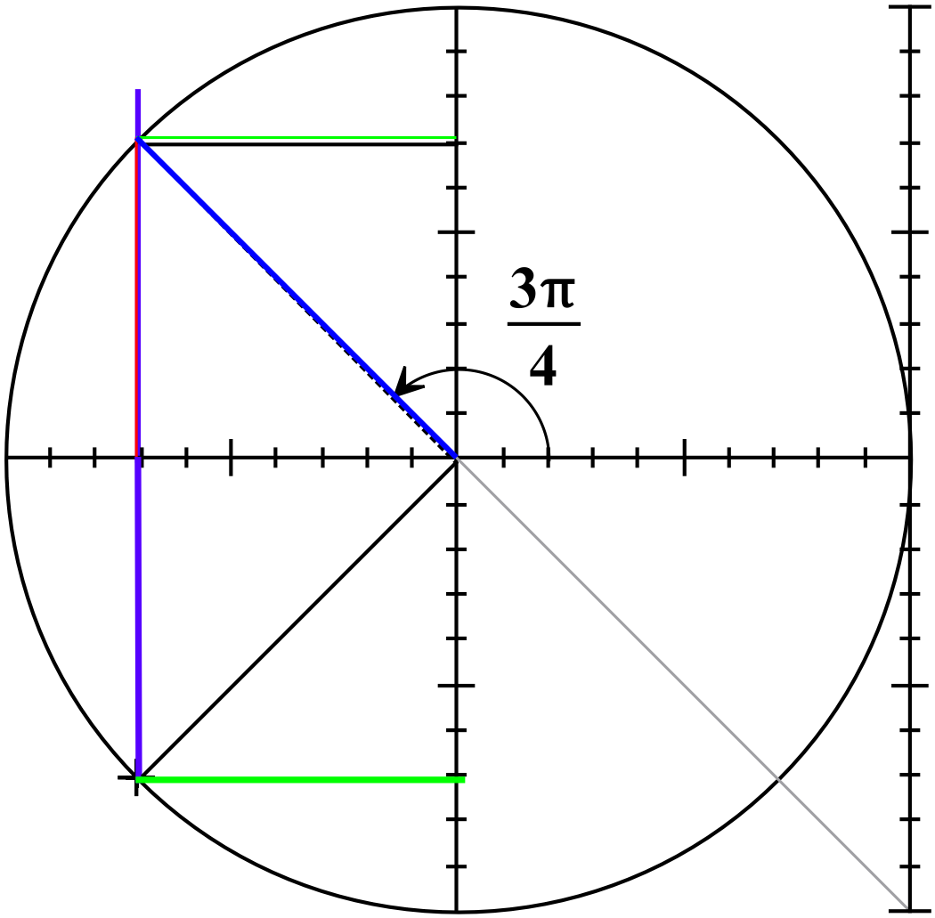
From exact values and use of unit circle,
Marking key/mathematical behaviours | Marks
- indicates method of determination on diagram  - states both correct values of | 1  1

Question 2(a)
Solution
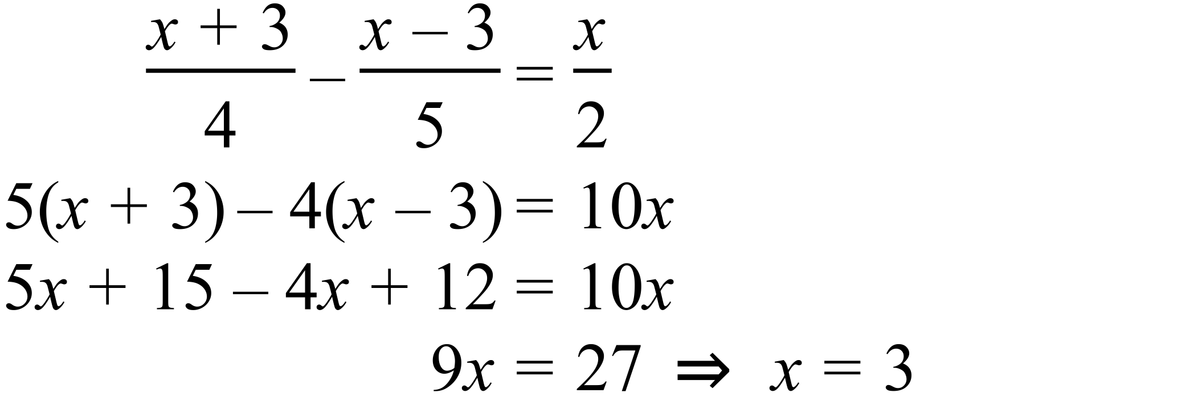

Marking key/mathematical behaviours | Marks
- multiplies the equation by the LCD  - expands brackets and simplifies  - solves for x | 1  1  1

Question 2(b)
Solution
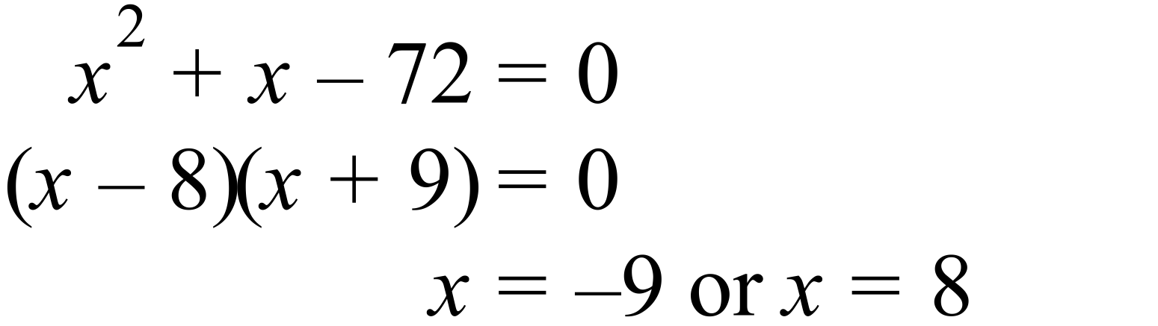

Marking key/mathematical behaviours | Marks
- factorises trinomial  - solves for x | 1  1

Question 2(c)
Solution
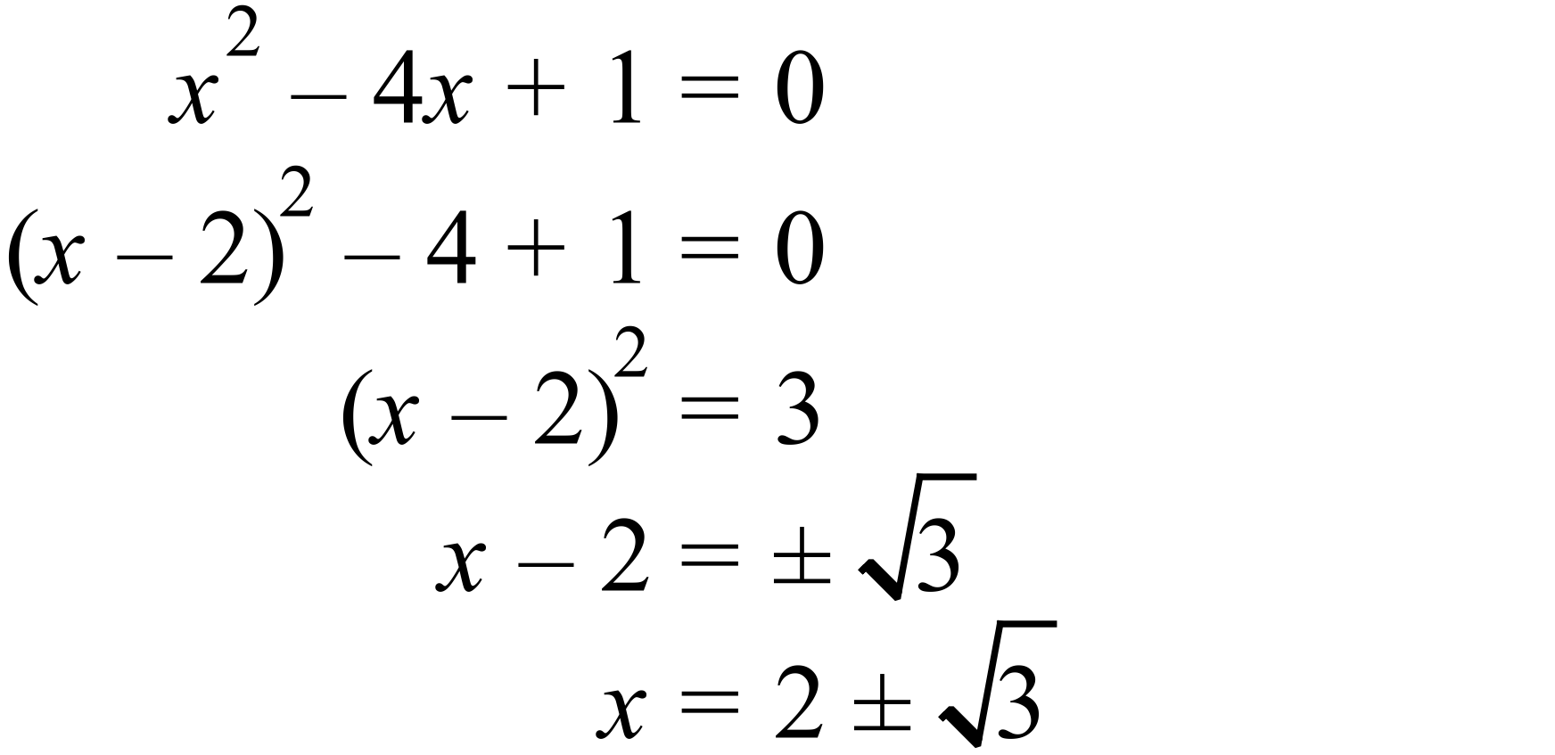
Marking key/mathematical behaviours | Marks
- completes the square  - equates 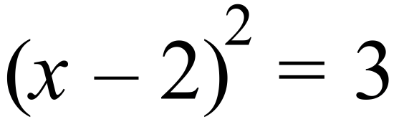  - takes square root  - solves for x | 1  1  1  1

Question 3
Solution
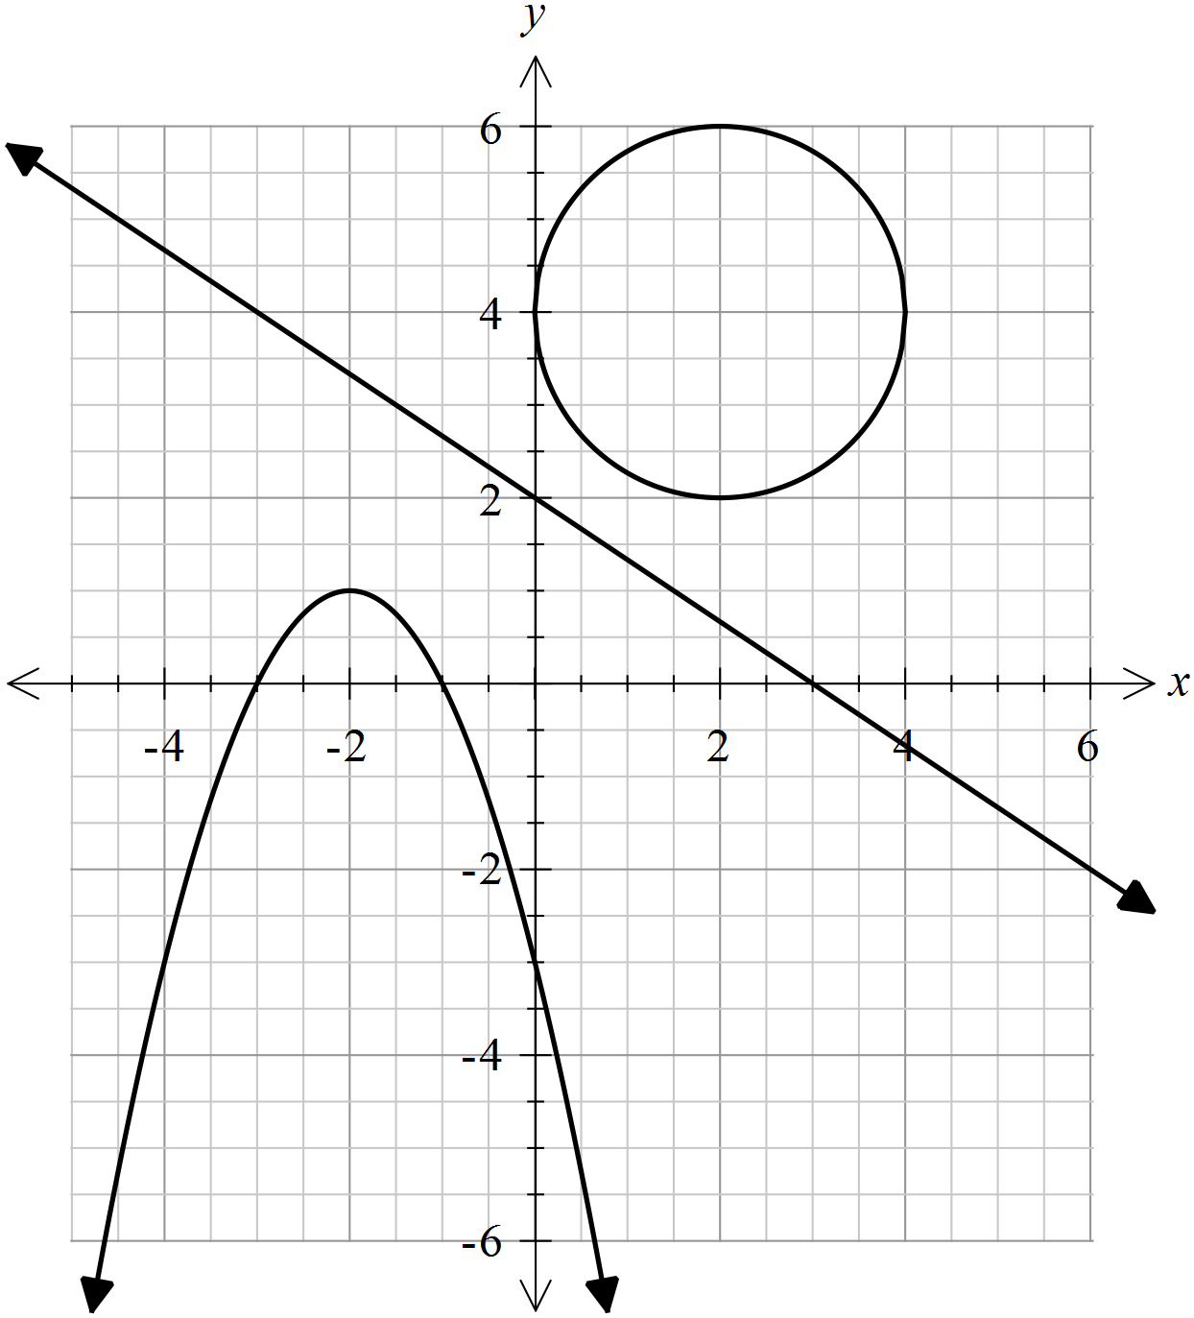

Marking key/mathematical behaviours | Marks
- sketches 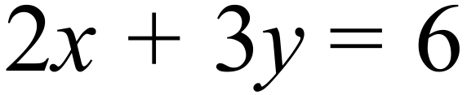 accurately, showing x and y intercepts  - sketches 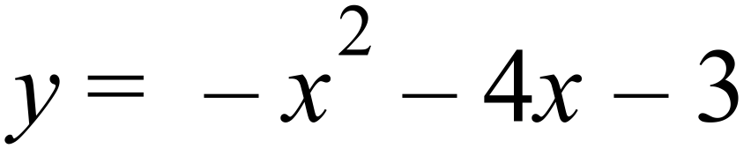reflecting the correct turning point, orientation and intercepts  - sketches 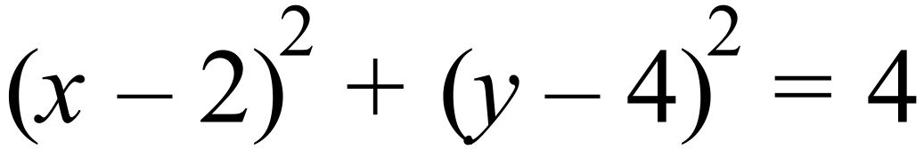 with correct radius and centre | 1+1  1+1+1  2

Question 4
Solution
Graph A:
Graph B: 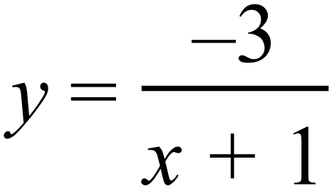

Marking key/mathematical behaviours | Marks
- Graph A  - correct horizontal translation  - recognition of reflection in  - Graph C  - correct horizontal translation  - correct dilation factor  - recognition of reflection in | 1  1  1  1  1

Question 5(a)
Solution
- From part (i), P(X) = 0.7 and P(Y)= 0.5
P(X) P(Y) = 0.35 0.3
Marking key/mathematical behaviours | Marks
(i)  - determines  - determines correct value for  (ii)  - determines  - shows that  - concludes that the two events are not independent | 1  1  1  1  1

Question 5(b)
Solution
Marking key/mathematical behaviours | Marks
(i)  - applies the conditional probability formula  - substitutes correctly  - multiplies correctly and simplifies  - determines correct value for  (ii)  - determines  - applies complimentary property and arrives at the correct result | 1  1  1  1  1  1

Question 6(a)
Solution
Has the form
Period = hence =
Vertical translation 1 unit up, hence = 1.
Dilation parallel to y axis, scale factor = 3. Hence, a = 3

Marking key/mathematical behaviours | Marks
- determines the period and hence  - identifies vertical translation and determines = 1  - determines  - states the correct equation | 1  1  1  1

Question 6(b)
Solution
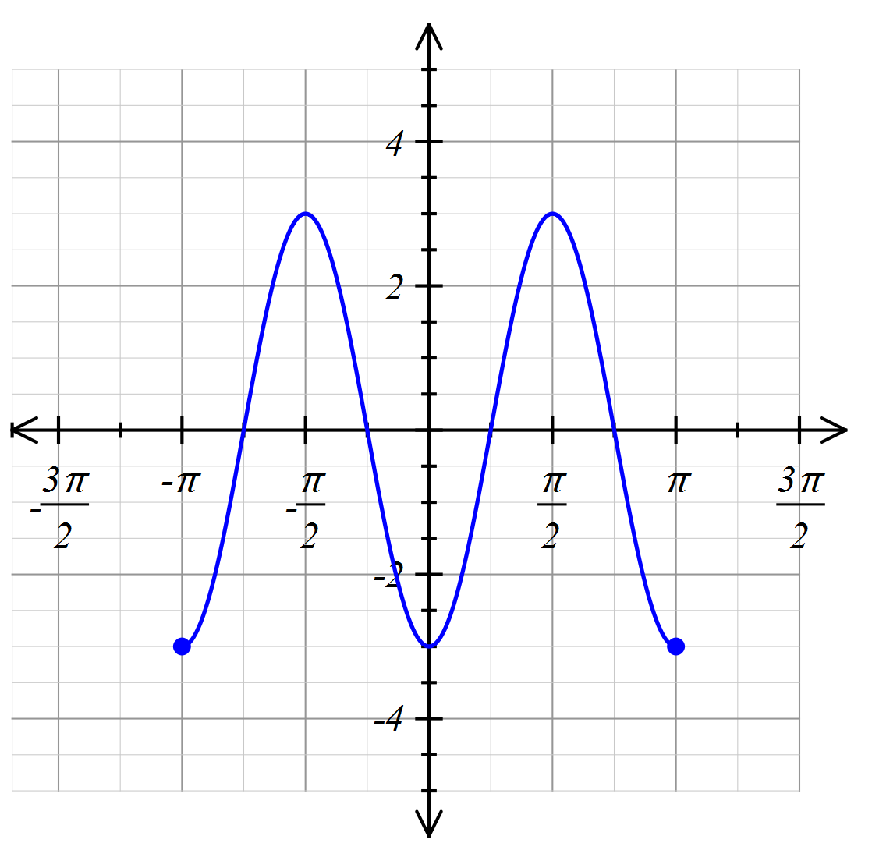

Marking key/mathematical behaviours | Marks
- graph is drawn over the correct domain  - graph is a cosine curve with the correct amplitude  - graph has the correct period  - phase shift is correct  - graph is accurate passing through (0,-3) and has smooth turning points | 1  1  1  1  1

Question 7 (a)
Solution
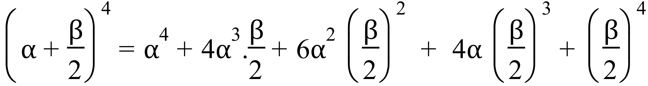
Marking key/mathematical behaviours | Marks
- uses the correct binomial coefficients  - each term has the correct powers for  - uses correctly in each term | 1  1  1

Question 7(b)
Solution
The mouse has six choices to enter and five choices to leave by another door.
So,
Marking key/mathematical behaviours | Marks
- states the correct result | 1

Question 7(c)
Solution
- There is only one card with an even number on it.(2)
There are six other numbers that the 2 can be combined with to give an even product.
- For the product to be prime, one of the cards must be ONE(1)
Any of the other six cards can be combined with 1 to give a prime product
- There are only 4 possible combinations of two of the numbers that sum to a prime number. 1+2, 2+3, 2+5, 2+11.

Marking key/mathematical behaviours | Marks
(i)  - states correct sample space  (ii)  - determines that there are 6 pairs of numbers (listing or logic) that have an even product and determines the correct probability of an even product  (iii)  - indicates that the only way that the product can be prime is if one of the cards has a one on it.  - determines the correct probability of a prime product  (iv)  - provides some form of exhaustive listing of the sum of two numbers  - determines that there are only 4 possibilities of prime sums  - determines the correct probability of the sum being prime | 1  1+1  1  1  1  1  1

